CLASS: VII (CASE STUDY)
CHAPTER 7: COMPARING QUANTITIES
PERCENTAGE INCREASE AND DECREASE OF A QUANTITY
1. Rahul owns a fruit shop. He sells apples, oranges and bananas. The table below shows the sales data for past two months.
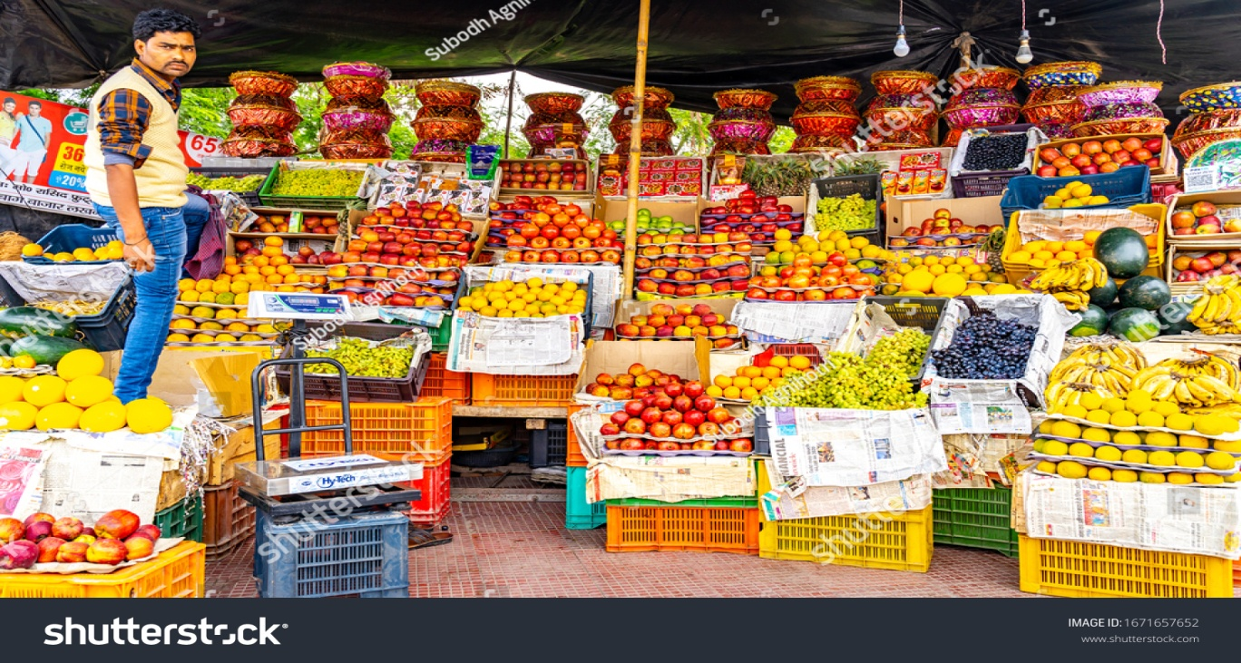

Name of fruits | Sales in September, 2024 (kg) | Price of fruits per kg in September | Sales in October, 2024 (kg) | Price of fruits per kg in October
Apples | 250 | 120 | 225 | 150
Oranges | 150 | 150 | 180 | 125
Bananas | 300 | 125 | 375 | 130
Answer the following questions using the data given above:
(a) Find the percentage decrease in apple sales from September to October, 2024.
(b) Find the percentage increase in the price per kg of bananas from September to October, 2024.
(c) Find out the percentage increase or decrease in the total amount of sales of Oranges from September to October, 2024.
(d) A customer bought 2kg apples, 1.5kg Oranges and 3 kg bananas in the month of September from Rahul’s shop. If he would buy the same quantity of each fruit in the month of October, 2024, then how much more would he have to pay for that? Calculate the increase or decrease in price also in percentage.

